 |  | 
 | Blackberry 7130G
 | 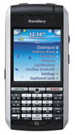 | Description  The 7130G is a quad-band GSM part of the 7100 series phones with 240x260 pixels display and SureType keyboard. It has high-speed EDGE data and runs on 312MHz Intel processor.  STORE PRICE: Rs 14,413 /-  ONLINE PRICE: Rs 13,874 /-
Brand : Blackberry
Model Name : 7130G
Released Year : 2006
Phone Memory : 64 MB flash memory
External Memory : No
Colors : Silver
Form : Bar
Dimensions : 115 x 56 x 18 mm
Weight : 120g

